Nepal College of Information Technology
Assessment
Fall 2010
Program: ELX Time: 3 hrs
Semester: Fall (III) FM: 100
Subject: EMFW PM: 50

The figures in the margin indicate full marks.
Attempt all the questions:
1 State Biot and Savart’s law with its application in magneto statics. 8
2. Define curl with its physical significance and distinguish between vector magnetic potential and scalar magnetic potential. 8
3. State Poisson’s and Laplace’s equation. How is it derived and what region is it valid? 8
4. State Ampere’s Circuital law. What is the conflict between Ampere’s Circuital law and equation of continuity? How can the conflict be solved? 8
5. Two conducting cones (θ = Π/10 and θ = Π/6) of infinite extent are separated by an infinitesimal gap at r = 0.If V (θ = Π/10) = 0and V (θ = Π/6) = 50 V; find V and E between cones. 10

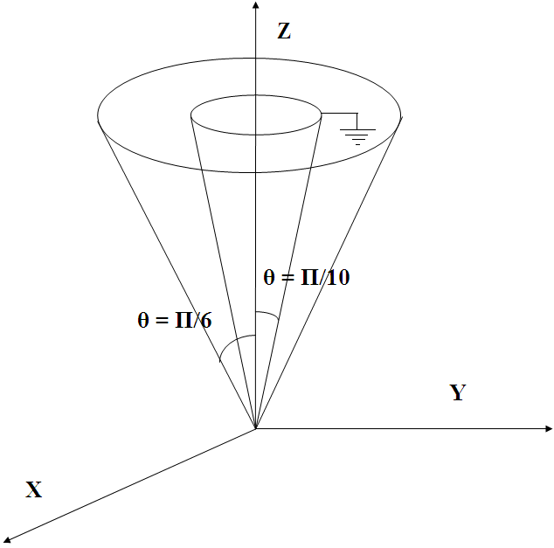
6. A vector field is given by the expression P = x²yz ax + xy az and scalar is given by V = e^{-z}Sin 2x Cosh y. Determine 4*2.5=10
i) ▽ V
ii) ▽ . P
iii) ▽ x P
iv) ▽²V
7. Transform the following to the cylindrical coordinate system:
a) F = 10 ax – 8ay + 6 az at point P(10,-8,6)
b) G = (2x + y) ax – (y-4x) ay at point Q(ρ, ϕ,z). 8
8. Potential is given by V=2(x+1)²(y+2)²(z+3)² V in free space. At a point P(2,-1,4) calculate
a) Potential at point P
b) Electric field Intensity E at point P.
c) Flux density D at point P.
d) Volume charge density ρv at point P. 4*2=8
9. State and derive continuity equation. 4
10. Find the work done in moving a 2C charge from the origin to the point (3,-1, 4) through the field E = 2xy ax + x²z ay + x²y az V/m via the straight path. 8
11. A (75 + j125) Ω load is connected to 72 Ω lossless line. Find
a) Γ
b) S
c) The load admittance Y_{L}
d) Z _{in} at 0.3 λ from the load(using Smith chart) 4*3=12
12. Write short notes (any two) 4*2=8
a) Electric Flux
b) Conservative fields
c) Coulomb’s law
d) Divergence theorem

